SSN COLLEGE OF ENGINEERING, KALAVAKKAM
DEPARTMENT OF COMPUTER SCIENCE & ENGINEERING
Internet Programming Lab – CS8661
Programming Assignment 2 - CSS Practice Excercises

- Create and test HTML document that has six short paragraphs of text that describe various aspects of the state in which you live. Define three paragraph styles p1, p2 and p3. The p1 style must use left and right margins of 20 pixels, a background color of pink, and a foreground color of blue. The p2 style must use left and right margins of 30 pixels, a background color of black, and a foreground color of yellow. The p3 style must use text indent of 1 cm, a background color of green, and a foreground color of white. The first and fourth paragraph must use p1, the second and fifth must use p2, and the third and sixth must use p3. Demonstrate using inline, embedded and external style sheet. Demonstrate using different selectors.

- Create web page with the following contents. Use two style sheets. Style1.css displays the paragraph in pink background color with blue color font. Style2.css displays the paragraph in green background color, yellow color font with letters of the paragraph being spaced “2em” between each other. Demonstrate the rendering of web page with different styles using web browser.

- Apply the following rules for the HTML document displayed in the figure.
  - Use yellow background color for the web page
  - Define alternative colors for anchor pseudo classes.
  - Make table caption boldface, table headers normal weight but italicized.
  - Use a 14 pt sans serif font for all td elements.
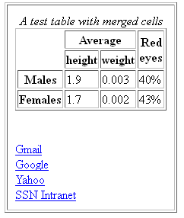

- Create a website for a school PS International Higher Secondary School. Divide the home page horizontally into two frames Frame1 (20%) and Frame2 (80%). Frame2 will be further divided into two vertical frames Frame3(20%) and Frame4(80%). Frame3 has links Home, Fee Structure, Academics, Acheivements, Results, Contact us.

Home page contains the following information:

The PS International Higher Secondary School is a recognized landmark in its pursuit of excellence in education, holistic development and human excellence, is deeply dedicated to the mission of building "Global Citizens with Indian Values", with an emphasis on value education, and respect for our rich cultural heritage.

PS International Higher Secondary School has been set up by the Learning Leadership Foundation (a public charitable trust) under the dynamic leadership of Dr. PS, Director. The PS International Higher Secondary School come directly under their purview and follow the tried and tested methodology of the teaching – learning process that has been the mainstay of academic excellence in over 50 years.

The Learning Leadership Foundation comprises a group of enterprising people, who
have considerable experience in education, and are recognized for 'professional development initiatives' for teachers. The School is backed by the combined strength of over a decade of 'thought leadership' in best pedagogic practices of the Learning Leadership Foundation and more than five decades of academic excellence of PS International Higher Secondary School. The option of the School Transportation is provided for all the Campus, in all the locations, both in Chennai.

Fee structure webpage
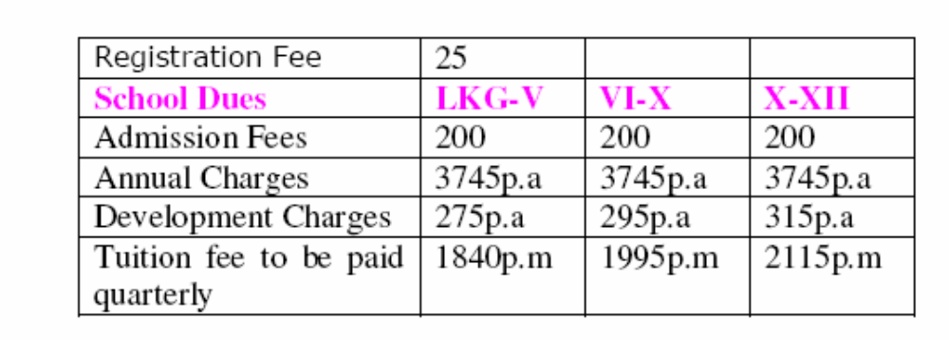
Acheivements Webpage
1. Hero Honda Inter Schools Athletics meet was held at Gems International School.
more than 40 schools of District Gurgaon participated in the meet. Director Hero
Honda was Chief Guest. Our participants brought many laurels to the school.
- Deepak Yadav (Class X) bagged the Gold Medal in boys under 18years
- Our Relay team Girls under 18 years got the Bronze Medal. The participants
were: Renu Yadav, Komal Yadav, Simral, Shereya
- Student Simral (Class VII) won a Silver Medal in age group under 14 years
and Bronze Medal in age group under 18 years.
- Nitesh Yadav (Class VIII) bagged the Gold Medal in age group Boys under
14 years.
2. Haryana State Roller Skating Championship was held at Faridabad from 17th Dec.
to 19th Dec. 2010. Our participants brought many laurels to the school. The results
are as follows:
3. Yuthika Khatri (Class VII) bagged Gold Medals and Bronze Medals in the
following events:
- 500 mtrs. Rink Race Gold Medal
- 5000 mtrs. Road Race Gold Medal
- 1000 mtrs. Rink Race Gold Medal

Answer the Following
- Enforce these styles into the web pages of the school website.
- Generally the text which needs to be emphasized should be displayed in pink and bold.
- A specified paragraph should be displayed in blue color, italic and font-size should be 13.
- All the links must be styled with pseudo class with different colors such as linked: red, visited: violet, hover: blue and active: yellow.
- Universal font-size 14
- Character data of list item of ordered list should be in italic and 0.5ex size
- Character data of list item of unordered list should be in cursive with 2 inches size
- A style sheet should be written for visually impaired facilitating the view of the contents with the following style background yellow, text in red color, font size in 15, letter spacing 1 em
- A Logo of the school must be placed in Frame1 at the left position and the name of the school should be centered.
- A logo of stamp size must be at the bottom right corner of every webpage of website. It should be attached to the position where it is placed even the user scrolls the webpage.
- Use embedded and external style rules.
- Find out how CSS cascading and inheritance are applied to the webpages of the website from the given style sheets

School Logo is
